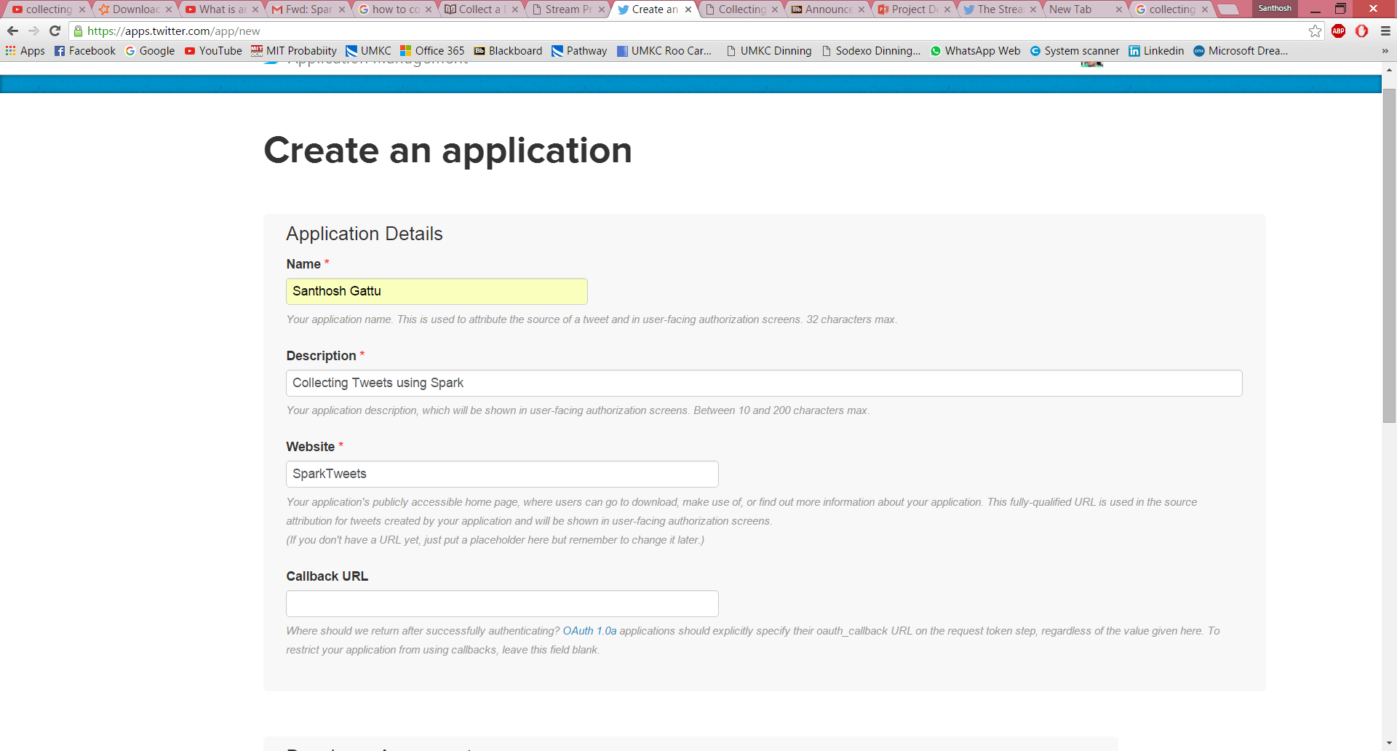

Website: <http://sparktweets.com>

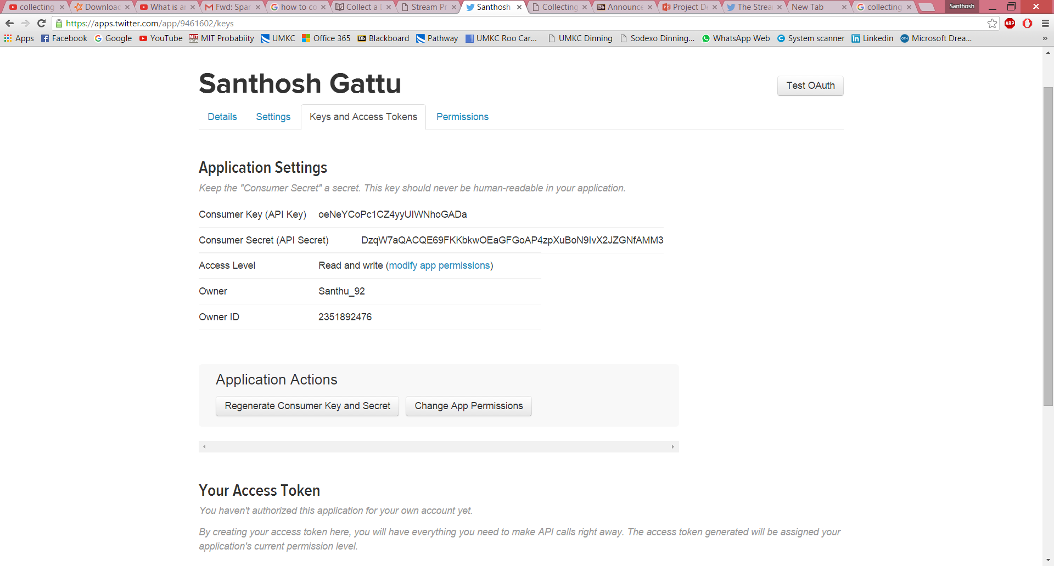

Consumer Key (API Key) oeNeYCoPc1CZ4yyUIWNhoGADa

Consumer Secret (API Secret) DzqW7aQACQE69FKKbkwOEaGFGoAP4zpXuBoN9IvX2JZGNfAMM3

Access LevelRead and write ([modify app permissions](https://apps.twitter.com/app/9461602/permissions))

OwnerSanthu_92

Owner ID2351892476

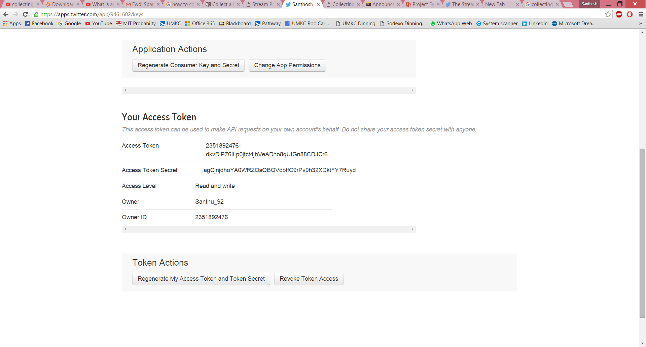

Access Token 2351892476-dkvDlPZ6iLp0jtct4jhVeADho8qUIGn88CDJCr6

Access Token Secret agCjnjdhoYA0WRZOsQBQVdbtfC9rPv9h32XDktFY7Ruyd

Access LevelRead and write

OwnerSanthu_92

Owner ID2351892476

Top of Form